PLACEMENT OF STUDENTS OF BATCHES 2017-2022

- Arpana Sarkar of 2017 batch has been recruited as UP Teacher under DEE Parbatia Girl MV School w.e.f. 9 Feb, 2021
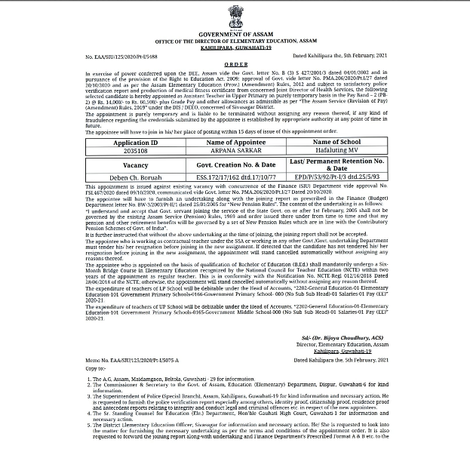
- Manmi Hazarika of 2017 batch has been recruited into the Financial Services And Insurance (BFSI) w.e.f. 18 Oct,2022
- Nilakhi Bora of 2017 batch has been recruited as a Teacher w.e.f. 5 Nov, 2019
- Hrishab Deka of 2017 batch has started working as an entrepreneur w.e.f. 28 Feb, 2021
- Parismita Deka of 2017 batch has been recruited as TET Teacher
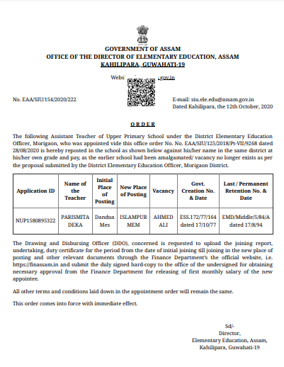
- Ruburanjan Patar of 2018 batch has been recruited as U Content Developer w.e.f. 25 April,2022
- Ankita Bharali of 2018 batch has been recruited as Asst.Professor (Ad-Hoc) at Jagiroad College w.e.f. 7 July, 2022
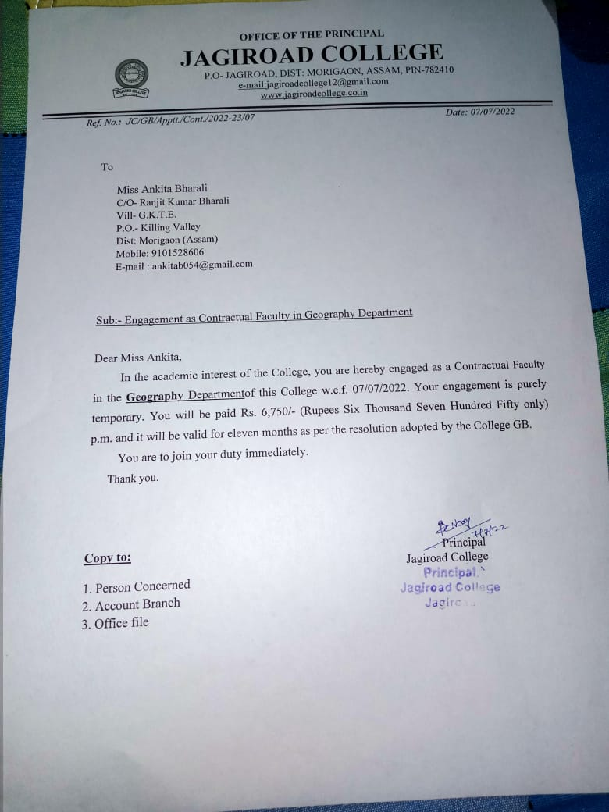
- Bikash Daimary of 2019 batch has been recruited into Assam Special, Reserved force of Assam Police w.e.f. 18 May, 2022
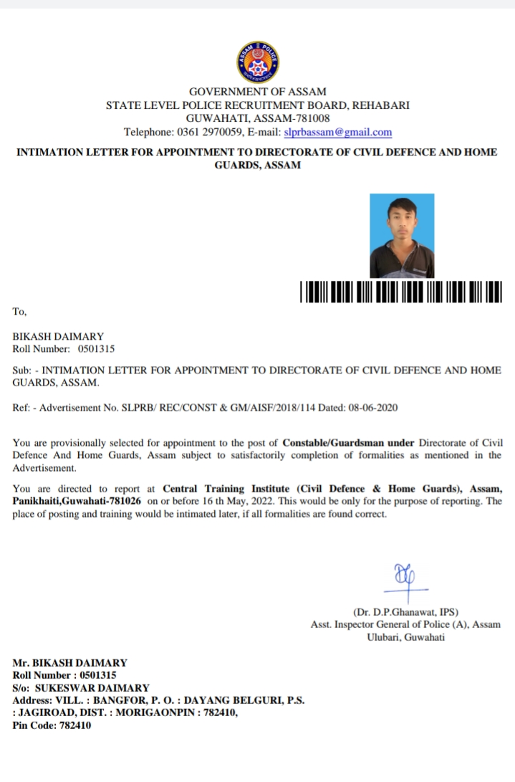
- Jupitara Saikia of 2019 batch has been recruited as Asst. teacher, Akanksha Junior College w.e.f. 2 Aug 2022
- Rim Rim Bordoloi of 2019 batch has been recruited as Office Assistant at Morigaon Sarathi AGRO Producer Company Limited w.e.f. 15 July 2021
- Neha Shestha of 2019 batch has been recruited as Soft Skill Trainer at Empower Progoti Vocational and Stafting Pvt.Ltd Under project DDU GKY w.e.f. 17 Dec,2021
- Ilina imran Thakuria of 2019 batch has been recruited as Brand Ambassador at Echo Booom management and solution Pvt. Ltd w.e.f. 27 July,2022
- Arup Bhatta of 2020 batch has been recruited as MIS Officer and customer care at SM Corporation Ltd. Under TATA AGRICO w.e.f. 1 Dec, 2021
- Rubi Das of 2020 batch has been recruited at the ICICI Bank at Hatigaon w.e.f. 23 Aug, 2022
- Binod Puma of 2021 batch has been recruited as Constable in UB Assam Police w.e.f. 23 Sep,2022
