ACHIEVEMENTS OF THE STUDENTS OF GEOGRAPHY DEPARTMENT IN THE DURATION BETWEEN THE YEARS 2017-2022
- Bikash Daimary & Prodeep Dutta, in the year 2017, have won Bronze medal at the National Level for International karate Championship organized by World Funakoshi Shotokan karate organization Mumbai, 2018
- Budha Boro, in the year 2017, won the first prize in the 4th Morigaon District Taekwondo Championship, 2017 organised by Charaibahi Taekwondo Association.
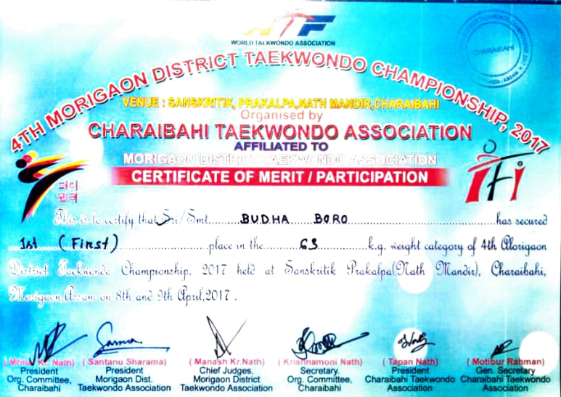
- Buddha Boro, in the year 2018, has won Gold medal in the University Level Inter College Boxing Competition (60 kg) organized by Gauhati University
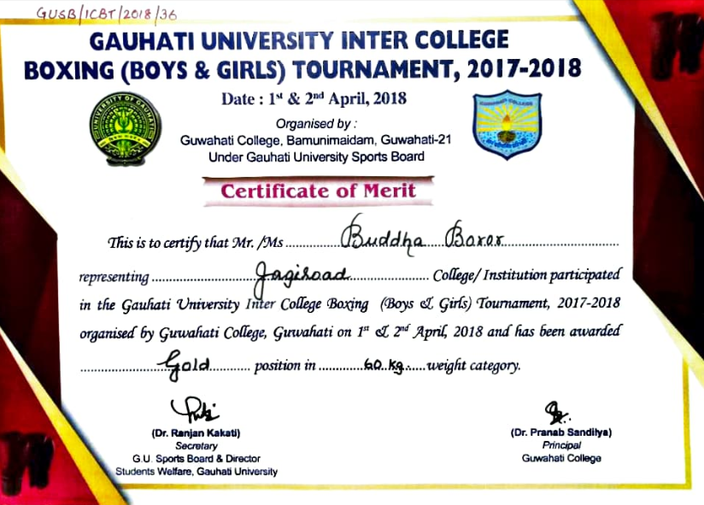
- Dhritismita Goswami, in the year 2018, has won Silver medal in the University Level Inter College Boxing Competition (60 kg) organized by Gauhati University
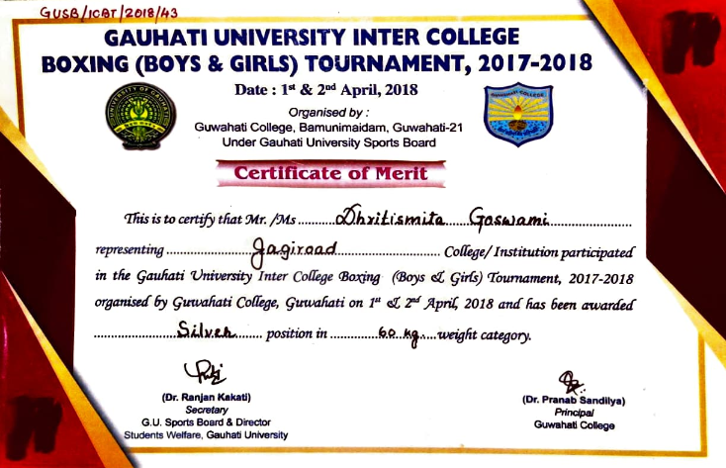
- Buddha Boro, in the year 2018, has won Bronze medal in the National Level For International Karate Championship organized by World Funakoshi Shotokan karate organization Mumbai,2018
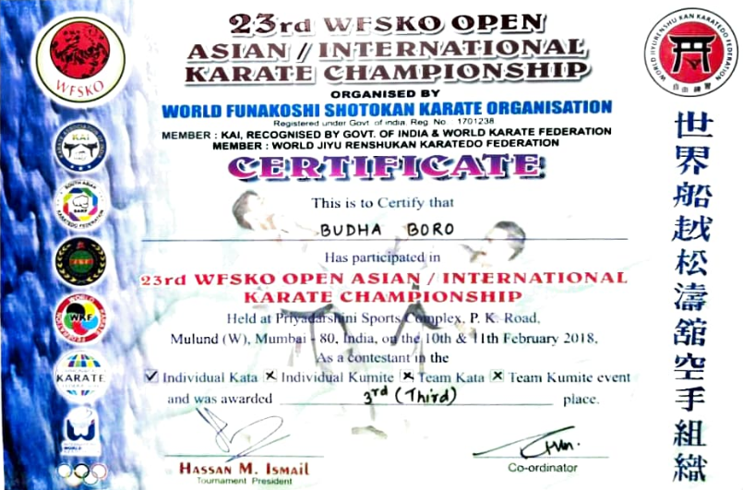

- Dhritismita Goswami, in the year 2018, has won First prize in the National Level Competition for National Hapkido Championship organized by Hapkido Association, Assam
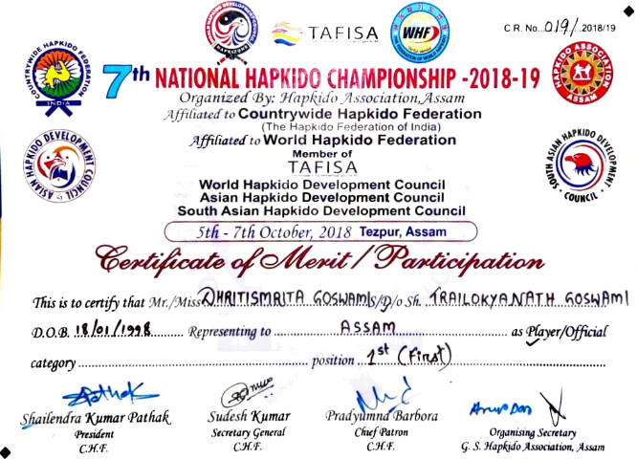
- Geography Department, in the year 2018, has won First prize in the Institutional level Wall Magazine competition organized by Jagiroad College
- Geography Department, in the year 2016, has won First prize in the Institutional level Cultural Procession organized by Jagiroad College
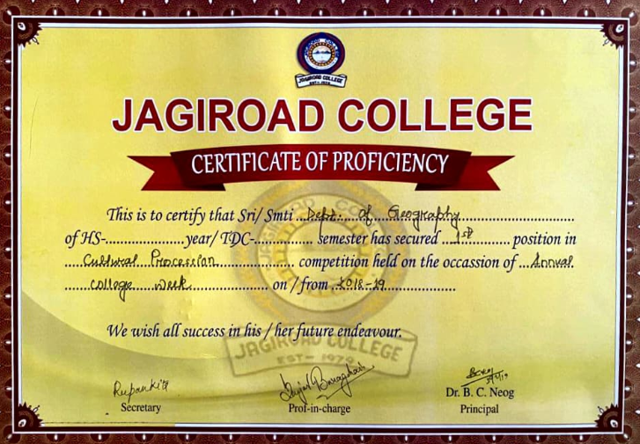
- Rica Bhowmick, in the year 2020 has won First prize at the District Youth Parliament organized by Nehru Yuva Kendra, Nagaon
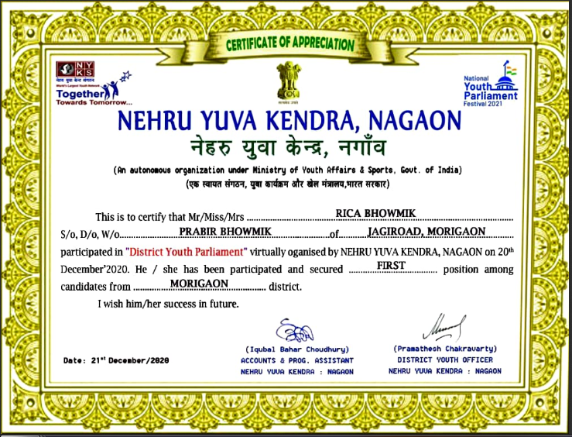
- Cdt. Binod Puma, in the year 2021, has won Overall Special Motivational Prize among all Units under 8th Assam Bn for Video and E poster Competition in rltn with World Environmental Day organized by 8th Assam Bn, Nagaon
- Nikita Gogoi, in the year 2021, was chosen as the College Campus Ambassador for the National Voters Day organized by District Ambasador. Morigaon
- Geography department, in the year 2022, has won First prize in the Wall Magazine Competition organized by Jagiroad College
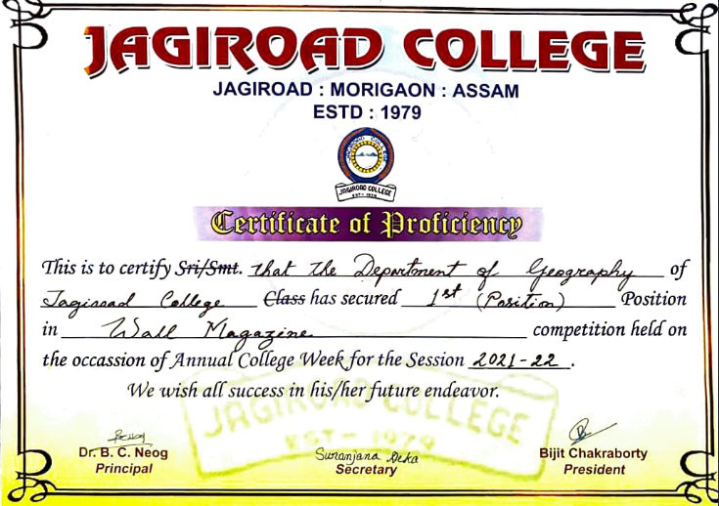
- Parismita Deka was the 2nd Best Graduate in Jagiroad College in the year 2017. She obtained 1258 marks out of a total of 1700 total marks.
- Dhritismita Goswami was the Best Graduate in Jagiroad College in the year 2018. She obtained 1389 marks out of a total of 1700 total marks.
- Budha Boro was the 2nd Best Graduate in Jagiroad College in the year 2019. He obtained 1230 marks out of a total of 1700 total marks.
- Banusmita Deka was the Best Graduate in Jagiroad College in the year 2020. She obtained 1396 marks out of a total of 1700 total marks.
- Rica Bhowmick was the Best Graduate in Jagiroad College in the year 2021. She obtained 1470 marks out of a total of 1700 total marks.

